TECHNO MACHINE TOOLS

Survey no:126/A/1, DOOR NO: 4-132-9/A/2, Gandimaisamma X Road,

Medchal Malkajgeri,Hyderabad-500043.Telangana, India.

(MANUFACTURERS OF MACHINE TOOLS)

T.SIVARAMAKRISHNA
ME., MBA.
---------------------------------------------------------------------------------------------------------------------------------

TMT/KRISHNA ENG/ S0199/2025 17-04-2025

To,
Sudhagar D
KRISHNA ENGINEERING WORKS, Flat No-372,Jeedimetla,Qutubullapur,Medchal-Malkajgiri, , Hyderabad - 500055, Telangana, India
Email: madhusudhagar143@gmail.com , suthagar1234567@gmail.com
Mobile: +(91)-9542103094 , 9100221478

Dear sir,

Sub :- Supply of HYDRAULIC PRESS BRAKE MACHINE. 2500x4

We are very much thankful to you for your kind conversation extended to us for detailed discussions in regard to the manufacturing of machinery that are required by you. As requested by you we are submitting hereunder the detailed specifications in item wise together with the make of standard peripherals that are connected to the respective machinery.

PRESS BRAKE :

1) Size : 2500 X 4M.M.

2) Tonnage : 80 M.T.

S No | Description of the unit | Offer
1. | Hydraulic Press Brake with bending capacity 2.5 Meters and 4 mm MS Sheet, 80 MT load capacity with Power pack of 7.5 HP motor along with one set Standard Die and Punch. | Rs.6,25,000/-(six lakh twenty five thousand only)

SPECIFICATIONS FOR THE HYDRAULIC PRESS BRAKE MACHINE WITH 2500 M.M. WIDTH AND 4 M.M. THICKNES.

1. Tonnage : 80 M.T.

2. Clearance between Housings : 1500 M.M.

3. Bending capacity in M.S. : 2500 x 4 M.M.

4. Ram stroke. : 100 M.M.

5. Open height. : 260 M.M.

6. Closed height. : 160 M.M.

7. Depth of Throat. : 300 M.M.

- Ram speeds.

a) Approach. : 36 M.M. per Sec.

b) Return. : 60 M.M. per Sec.

9. Motor capacity. : 7.5 H.P. (Crompton)

10. Punch. : 2500 x 160 x 25 M.M.
( ‘GROOSE NECK’ type)

11. Bed size. : 2500 x 165x45 M.M.

12. Cost of Machine. : Rs.6,25,000/- + Taxes.

13. Mode of payment. : As per the quotation.

14. Delivery. : As per the quotation.

GENERAL TERMS & CONDITIONS:

- Price quoted per unit ex-work. Hyderabad.
- Following charges are additional to your account.
- Freight Charge : As actual to be borne by you.
- Tax : 18% as applicable
- Packing charge : As actual to be borne by you.
- Insurance : As actual to be borne by you.
- Payment : 50% advance along with order another 25%
advance after 3 weeks from first advance and
balance before delivery but after inspection at our
works.
- Delivery : 8-10 weeks from date of techno-commercially clear
purchase order.
- Validity : One month from the date of submission.
- Inspection : Inspection at our works prior to dispatch.
- Warranty : The cylinder is warranted for a period of 12
months from the date of dispatch against any
manufacturing defects/faulty material or bad
workmanship of any part or component but not
against any kind of abnormal or improper use of
machine. Defective part or component will be
replaced or repaired free of cost. Electrical
components are outside the scope of this
warranty.
- Commissioning : Erection & commissioning done by you, but if
required technical support & guidance provide by
us at additional cost.

NOTE:
- Hyd. Oil is not in scope of our supply.
- Raw material for trial is arrange by you at your cost.

We are sure you will find our offer in line with your requirements. Should you require any further clarification please call us on mobile number (+91) - 9246221106./ +91- 9849207176

Thanking you and assuring you of our best services.

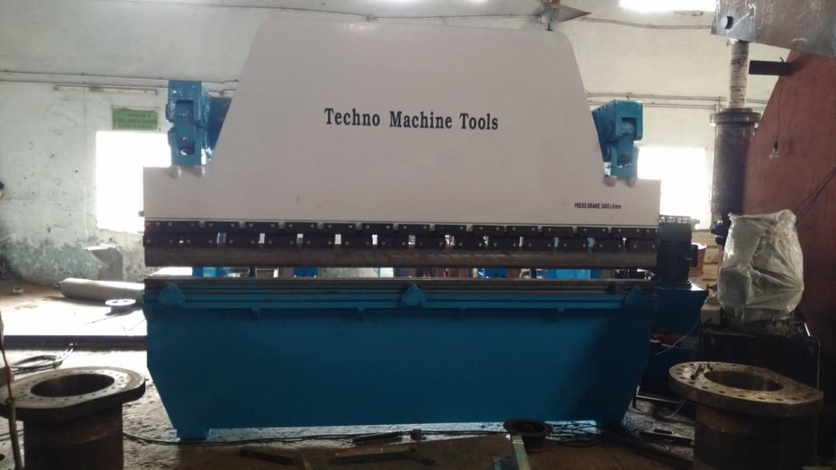

For TECHNO MACHINE TOOLS

- SIVARAMAKRISHNA

